It’s an age-old question: Can money buy happiness?
Over the past few years, new research has given us a much deeper understanding of the relationship between what we earn and how we feel. Economists have been scrutinizing the links between income and happiness across nations, and psychologists have probed individuals to find out what really makes us tick when it comes to cash.
The results, at first glance, may seem a bit obvious: Yes, people with higher incomes are, broadly speaking, happier than those who struggle to get by.
But dig a little deeper into the findings, and they get a lot more surprising—and a lot more useful.
In short, this latest research suggests, wealth alone doesn’t provide any guarantee of a good life. What matters a lot more than a big income is how people spend it. For instance, giving money away makes people a lot happier than lavishing it on themselves. And when they do spend money on themselves, people are a lot happier when they use it for experiences like travel than for material goods.
With that in mind, here’s what the latest research says about how people can make smarter use of their dollars and maximize their happiness.

Experiences Are Worth More Than You Think
Ryan Howell was bothered by a conundrum. Numerous studies conducted over the past 10 years have shown that life experiences give us more lasting pleasure than material things, and yet people still often deny themselves experiences and prioritize buying material goods.
So, Prof. Howell, associate professor of psychology at San Francisco State University, decided to look at what’s going on. In a study published earlier this year, he found that people think material purchases offer better value for the money because experiences are fleeting, and material goods last longer. So, although they’ll occasionally splurge on a big vacation or concert tickets, when they’re in more money-conscious mode, they stick to material goods.
But in fact, Prof. Howell found that when people looked back at their purchases, they realized that experiences actually provided better value. “What we find is that there’s this huge misforecast,” he says. “People think that experiences are only going to provide temporary happiness, but they actually provide both more happiness and more lasting value.” And yet we still keep on buying material things, he says, because they’re tangible and we think we can keep on using them.
Cornell University psychology professor Thomas Gilovich has reached similar conclusions. “People often make a rational calculation: I have a limited amount of money, and I can either go there, or I can have this,” he says. “If I go there, it’ll be great, but it’ll be done in no time. If I buy this thing, at least I’ll always have it. That is factually true, but not psychologically true. We adapt to our material goods.”
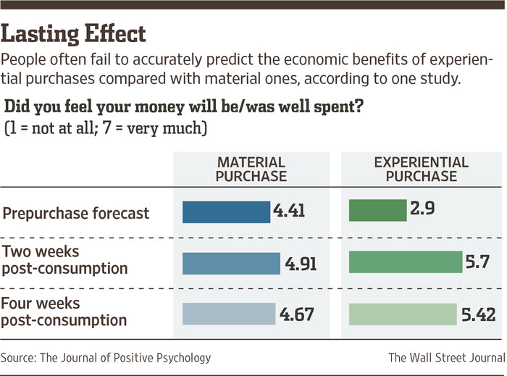
It’s this process of “hedonic adaptation” that makes it so hard to buy happiness through material purchases. The new dress or the fancy car provides a brief thrill, but we soon come to take it for granted.
Experiences, on the other hand, tend to meet more of our underlying psychological needs, says Prof. Gilovich. They’re often shared with other people, giving us a greater sense of connection, and they form a bigger part of our sense of identity. If you’ve climbed in the Himalayas, that’s something you’ll always remember and talk about, long after all your favorite gadgets have gone to the landfill.
And, crucially, we tend not to compare our experiences with other people so much. “Keeping up with the Joneses is much more prominent for material things than for experiential things,” he says. “Imagine you’ve just bought a new computer that you really like, and I show up and say I’ve paid the same amount for one with a brighter monitor and faster processor. How much would that bug you?”
In experiments he’s run, it bugs people a lot. But when people are told to imagine they’ve gone on vacation to New Zealand, and someone else has had a slightly better vacation, “it bothers people somewhat, but you still have your own experiences and your own memories, and so it tends to trouble you less.”
In a recent paper called “Waiting for Merlot,” Prof. Gilovich and colleagues showed that we also get more pleasure out of anticipating experiences than anticipating the acquisition of material things. People waiting for an event were generally excited, whereas waiting for material things “seemed to have an impatient quality.”

Don’t Adapt to What You Buy
One of the main reasons why having more stuff doesn’t always make us happy is that we adapt to it. “Human beings are remarkably good at getting used to changes in their lives, especially positive changes,” says Sonja Lyubomirsky, psychology professor at the University of California, Riverside. “If you have a rise in income, it gives you a boost, but then your aspirations rise too. Maybe you buy a bigger home in a new neighborhood, and so your neighbors are richer, and you start wanting even more. You’ve stepped on the hedonic treadmill. Trying to prevent that or slow it down is really a challenge.”
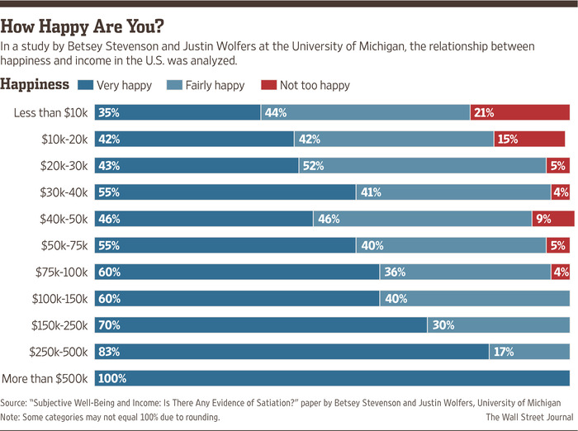ENLARGE
One approach that can work, she says, is consciously trying to foster appreciation and gratitude for what you have. The process of adaptation, after all, comes from taking what you have for granted, so you can slow it down by reminding yourself of why you value what you have.
It could be as simple as setting aside time every day to follow the traditional advice of “counting your blessings.” Or you might want to keep a daily journal or express your gratitude to other people. The key is to find a way to remain conscious of everything you own and avoid simply adapting to having it around.
Because you’re working against your natural inclination, Prof. Lyubomirsky acknowledges that feelings of gratitude and appreciation can be very difficult to sustain. If your journal or daily list becomes just a stale routine, it will no longer have much effect. You might have to keep switching techniques.
Increasing variety, novelty or surprise can also help you to enjoy your possessions more. “When things become unchanging, that’s when you adapt to them,” Prof. Lyubomirsky says.
If you keep a painting hanging in the same spot on the same wall, for example, you’ll stop noticing it after a while. But swap it with a painting from another room, and you’ll see each of them with fresh eyes, and appreciate them more. Try sharing your possessions with other people, too, and opening yourself up to new experiences, she says.
This could even mean depriving yourself of your possessions for a while, perhaps by lending them or sharing them with someone else. Elizabeth Dunn, associate professor of psychology at the University of British Columbia and co-author of the book “Happy Money,” recently conducted an experiment where she sent people home with a big bag of chocolate, telling some of them to eat as much of it as they could and others that they were forbidden to eat it. A third group could choose how much to eat.
The result? The people who had been forbidden from eating chocolate were able to enjoy their next chocolate bar much more than those who’d either eaten a lot or consumed their normal amount. “Giving something up temporarily can actually help to preserve our capacity to enjoy it,” Prof. Dunn says.
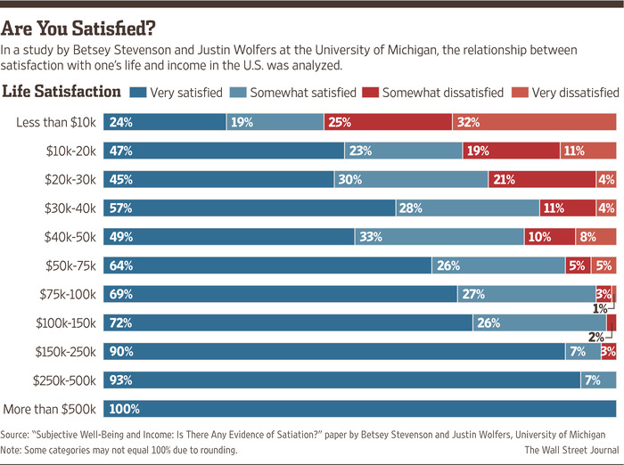

Try Giving It Away
The paradox of money is that although earning more of it tends to enhance our well-being, we become happier by giving it away than by spending it on ourselves.
That’s the finding from a series of studies by Prof. Dunn. She began by handing out cash to students on campus and telling some to spend it on themselves and others to spend it on someone else. Those who spent money on other people were happier than those who treated themselves.
Prof. Dunn has since repeated the experiment in other countries across the world, and has extended it to look at whether people were still happy when giving away their own money rather than free money handed to them by a professor. She found that in countries as diverse as Canada, South Africa and Uganda, giving away money consistently made people happier. This was even true when people were giving away their own money, and even when they themselves were relatively poor.
She also worked with economists to analyze survey data from 100 countries in the Gallup World Poll, and found that people who donated money to charity were happier, in poor and rich countries alike.
“The fact that we were able to observe the same effect that we’d seen in Canada in places like South Africa and Uganda was probably the biggest surprise of my career,” she says. “A lot of us think we’ll give to charity one day, when we’re richer, but actually we see the benefits of giving even among people who are struggling to meet their own basic needs.”
What moves the needle in terms of happiness is not so much the dollar amount you give, Prof. Dunn says, but the perceived impact of your donation. If you can see your money making a difference in other people’s lives, it will make you happy even if the amount you gave was quite small.

Be Sure to Buy Time, Too
It’s also important to consider how what you’re buying will affect how you spend your time. That big house in the suburbs may seem like a good idea, but a 2004 study by Alois Stutzer and Bruno Frey of the University of Zurich found that people with longer commutes reported lower overall life satisfaction, all other things being equal. They calculated that you would need a 40% raise to offset the added misery of a one-hour commute.
“Use money to buy yourself better time,” says Prof. Dunn. “Don’t buy a slightly fancier car so that you have heated seats during your two-hour commute. Buy a place close to work, so that you can use that final hour of daylight to kick a ball around in the park with your kids.”
Another way to buy yourself time, Prof. Dunn says, is by outsourcing tasks you dislike. Whereas hiring personal assistants used to be the preserve of the wealthy, it’s now easier and more affordable to hire freelancers and virtual assistants online to help you with either regular administration or just individual tasks.
She’s currently doing research on how people actually spend the time they save by outsourcing tasks and whether it makes them happier. The preliminary findings, she says, are that most people do become happier by buying time for themselves, but only if they use the time in the right way.
“Our hypothesis is that people will be much more likely to derive an emotional benefit if they think of it as ‘windfall time’ and use it to do something good, rather than just taking it for granted,” she says.
But while buying time is a good idea, putting a dollar value on your time may not be. In another piece of research in progress, Prof. Dunn is finding that when people think of their time as money, it makes them less likely to spend even small amounts of time on things that are not financially compensated. “Seeing time as money may have a number of destructive consequences,” she says.

Money Only Brings Happiness Up to a Point

When looking at all of these research results, there’s an important caveat to bear in mind. Those in the field divide happiness into two components, and you need to have both parts working together to be truly happy. But only one of those components keeps improving the more you earn. The other tops out after a certain point.
The first measure of happiness is “evaluative.” Prof. Lyubomirsky defines it as “a sense that your life is good—you’re satisfied with your life, you’re progressing towards your life goals.” That’s the measure used by economists Justin Wolfers and Betsey Stevenson, who have conducted extensive research comparing economic data and happiness surveys across the world. “We found very clear evidence that in just about every country around the world, rich people are happier than poor people,” says Prof. Wolfers. “And people in rich countries are happier than people in poor countries.”
The other component of happiness—“affective”—looks at how often you experience positive emotions like joy, affection and tranquility, as opposed to negative ones, explains Prof. Lyubomirsky. “You could be satisfied with your life overall but you may not actually be happy at the time,” she says. “Of course, happy people experience negative emotions, just not as often. So you have to have both components.”
Daniel Kahneman and Angus Deaton of Princeton University found that when they looked at affective measures, happiness did not rise after a household reached an annual income of approximately $75,000. (They did, however, find a consistent rise in overall life satisfaction, matching the results of Profs. Wolfers and Stevenson.)
The bottom line: When you don’t have much money, a little extra can go a long way, because you have more essential needs to fulfill. As you accumulate more wealth, however, it becomes more difficult to keep “buying” more happiness.

Don’t Get in Over Your Head
Finally, although much of the research in this field is on spending money rather than saving it, the researchers agree that spending more than you can afford is a route to misery. Taking care of your basic needs and achieving a level of financial security is important.
Prof. Gilovich says that although his research shows that life experiences give more happiness than material goods, people should of course buy the essentials first. His findings hold true across a broad range of income levels and demographic groups, but not for people with very low incomes. “Those people don’t really have discretionary income; it pretty much all has to go on necessities,” he says.
Some studies, meanwhile, have shown that debt has a detrimental effect on happiness, while savings and financial security tend to boost it. A survey of British households found that those with higher levels of debt reported lower happiness, and a separate piece of research on married couples showed that those in more debt had more marital conflict.
“Savings are good for happiness; debt is bad for happiness. But debt is more potently bad than savings are good,” Prof. Dunn says. “From a happiness perspective, it’s more important to get rid of debt than to build savings.”
So before you go out and spend all your money on a dream vacation, make sure you’ve taken care of the basics, paid off your debts, and have enough money to shield yourself from the worst of life’s troubles.
“Financial advisers are actually right,” Prof. Howell says. “The first thing you should be doing with your money is building up a safety net. If you go into debt to buy these great life experiences, the stress you’ll feel when the credit-card bill comes in will probably wipe out the good that you got from the experience.”
Mr. Blackman is a writer in Crete. He can be reached at reports@wsj.com.

