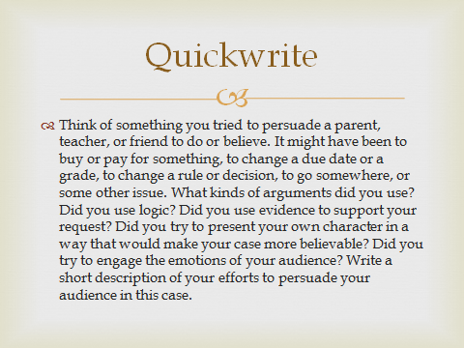

Please write two paragraphs in response to this prompt.

