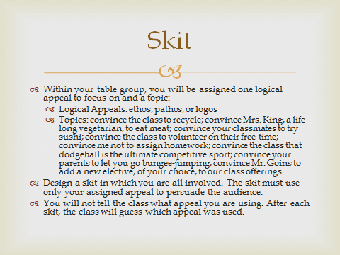
Absent students: Please pick a logical appeal and a topic. Write a script showing how you would act out a short skit. The script should focus only on one logical appeal.

