“A Change of Heart About Animals”
Absent Students please complete the warm-up first.
Then, do the vocabulary chart.
Afterwards, complete the prediction and the brief evaluation of the author (first two bullet points on slide “First Read”)
Finally read the article using the annotations (third and fourth bullet points on the slide “First Read”)
Once you have read the article divide it up. Chunk paragraphs together that relate. Take a look at the example. There I grouped paragraphs 1 & 2.
Create the Say + Do chart. For each chunk of paragraphs, complete a Say and Do.
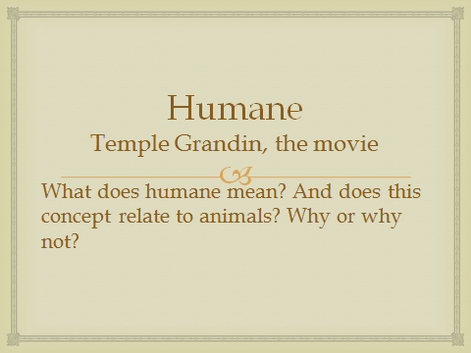
WARM-UP: Video Links—These videos present an individual who sought to treat animals in a certain way:
- https://www.youtube.com/watch?v=bnI_Y8PyTHM
- https://youtu.be/0Ff9eW0vEj0
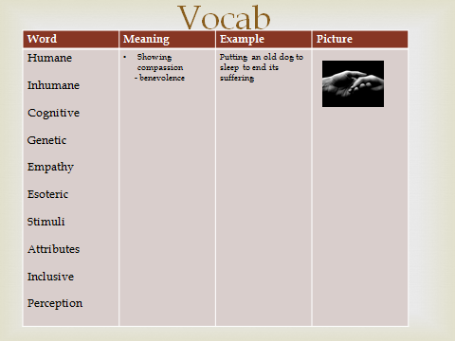
VOCABULARY CHART example
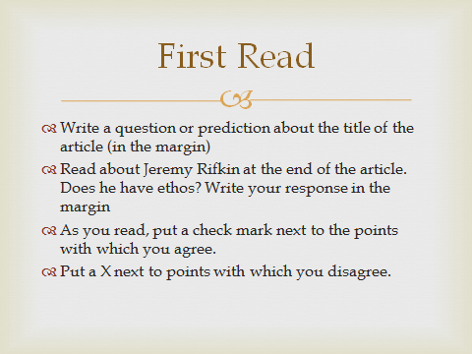
FIRST READ SLIDE
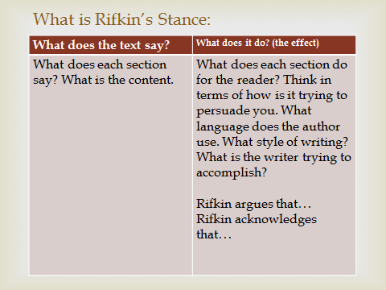
SAY + DO CHART

